Stock Code: 600057 Stock Abbreviation: Xiamen Xiangyu

Xiamen Xiangyu Co., Ltd.
2024 Annual Report (Summary)

To Shareholders

In 2024, as the global economy and trade order underwent accelerated restructuring, international industrial cooperation and competition entered a new stage. Throughout the year, we remained confident in our development path, seized emerging opportunities amid challenges, achieved steady progress in our core operations. Our key businesses not only advanced in scale but also improved in quality, driving the Company’s overall recovery and growth momentum.
Amidst market headwinds, we pressed ahead with greater resilience and reinforced our resolve to navigate through economic cycles. First, we continued to solidify our development foundation. We advanced business model upgrades, strengthened our risk management framework, optimized our customer portfolio, enhanced organizational capabilities, and accelerated digital and intelligent transformation, all contributing to quality and efficiency enhancements that fuel our high-quality development. Second, we made significant strides in our competitive edge. The successful completion of our refinancing project significantly strengthened our capital structure and opened new chapters in resource sharing, technological collaboration, and market expansion. Third, we ensured continuity through smooth management team transition. With seamless management succession, the Xiangyu spirit has been carried forward. Our journey from strength to excellence continues with unwavering momentum.
Looking back, as the international economic order continued to shift, China’s economy has shifted from rapid growth to high-quality development. In this evolution, Xiamen Xiangyu’s core competitiveness stems not only from a solid foundation but also from our resilience and innovation. Our resilience is reflected in our ability to maintain stable delivery amid global supply chain fluctuations. We have strategically positioned ourselves across key logistics hubs both at home and abroad, integrating each segment of the industrial chain to build a resilient, end-to-end supply chain service platform. Our innovation comes from forward-looking investment in the digitalization and greening of the supply chain industry. We are accelerating the application of advanced technologies such as AI and blockchain in supply chain scenarios, fostering unique industrial synergy advantages in strategic sectors like new energy and advanced manufacturing, and continuously increasing our transformation toward a more digital, intelligent, and sustainable supply chain ecosystem.
Looking ahead to 2025, as technological revolutions, industrial transformations, and global power dynamics continue to intertwine, we will move forward with greater foresight and resolve, continue to weave a resilient and interconnected global supply chain service network, intensify our efforts in resource integration and strategic channel deployment, while fostering an innovation-driven industrial ecosystem, a green and sustainable business model, and a resilient and high-performance supply chain system that together will serve as the engine driving the future of the industry.
As the tide of progress surges forward, we are poised to embark on a new journey with full sails. With the strong support of our shareholders and all sectors of society, we will stand united and move forward together, maintaining an enterprising spirit that never wavers, and a bold, resolute drive to forge ahead. Staying proactive and committed, we will steadily advance toward our vision of becoming a world-class supply chain service enterprise, striving to create greater value for our customers and investors alike.

Xiamen Xiangyu Co., Ltd.
Chairman: Jie Wu
April 22, 2025

I. Key Accounting Data and Financial Indicators
Unit: RMB Million
 | FY2024 | FY2023 | YoY  Change  (%) | FY2022
Total Assets | 123,872.66 | 129,705.19 | -4.50 | 115,119.21
Equity Attributable to the Shareholders of the Listed Company | 23,821.81 | 20,841.31 | 14.30 | 17,091.57
Operating Revenue | 366,670.61 | 459,035.45 | -20.12 | 538,148.06
Net Profit Attributable to the Shareholders of the Listed Company | 1,418.82 | 1,573.94 | -9.86 | 2,636.90
Net profits  Attributable to the  Shareholders of the Listed Company before  Nonrecurring Gains  and Losses | 406.50 | 507.30 | -19.87 | 2,655.99
Net Cash  Generated from  Operating Activities | 5,604.44 | 5,586.55 | 0.32 | 6,222.99
Weighted Average Return on Net Assets (%) | 7.15 | 9.29 | Decrease by 2.14 ppt | 18.06
Basic Earnings Per Share (RMB/share) | 0.48 | 0.63 | -23.81 | 1.10
Diluted Earnings Per Share (RMB/share) | 0.48 | 0.63 | -23.81 | 1.10

II. Industry Analysis During the Reporting Period
- Analysis of the Industry's Operating Conditions
In 2024, China’s economy sustained stable and progressive growth, with high-quality development advancing steadily and new quality productive forces evolving incrementally. However, confronted with a complex and severe landscape marked by mounting external headwinds and internal constraints, China's bulk supply chain enterprises continued to grapple with multifaceted challenges: first, year-on-year profit declines among industrial enterprises increasing pressure on profit margins across certain industrial chains, thereby squeezing profitability for supply chain service providers; second, persistent sluggishness in downstream manufacturing demand, coupled with price volatility and inventory buildup in distribution channels, further undermined commodity circulation efficiency; third, escalating unilateralism and protectionism, impediments to multilateral trade frameworks, and proliferating tariff barriers jeopardized the stability of global industrial and supply chains, disrupting the smooth flow of international economic activity.
In response to market changes, leading bulk supply chain enterprises leverage their service advantages and channel capabilities, focusing on core product categories to further increase their market shares in niche segments. They optimize customer and supplier structures, diversify upstream and downstream channels, and mitigate operational risks. Additionally, they adjust product portfolios to tap into structural opportunities within the industry, hedging against cyclical fluctuations. Seizing strategic momentum, they expand into key manufacturing segments of the industrial chain, securing critical positions. Furthermore, they actively develop international clientele to access incremental markets and explore digital and intelligent application scenarios to enhance supply chain efficiency.
Over the past year, while profits of industrial enterprises remained in decline, the prompt implementation of a comprehensive policy portfolio has facilitated a sustained recovery in industrial performance, with a gradual rebound in the supply chain sector's profitability. Although persistent geopolitical tensions have heightened volatility risks in international markets, they have simultaneously reinforced Chinese enterprises' determination to expand globally, indicating continued vast potential for international supply chain development. Concurrently, technological innovations such as AI are progressively being integrated into industrial and supply chains, potentially driving transformative upgrades in supply chain efficiency and operational paradigms.
In 2025, China's economic development will continue to face a complex and challenging external environment. However, the country's fundamental trend of long-term economic improvement remaining unchanged. As the government adopts more proactive and effective macroeconomic policies, the procurement demand for bulk raw materials will be stimulated and credit risks among customers are set to ease. Against this backdrop, the bulk supply chain industry is expected to witness marginal improvements in both demand and profitability, with leading enterprises demonstrating enhanced operational resilience.
- Industry Development Trends
- Industry Restructuring Creates Share Gains and Integration Opportunities for Leading Companies
Surging volatility in global commodity prices, coupled with cyclical and structural headwinds across select industries, has heightened operational pressure on bulk commodity supply chain players. Top-tier companies, relying on strengths in resource access, value-added services, and risk control, are actively scaling their channel networks and capturing greater market share, showcasing strong counter-cyclical expansion capacity. On a volume basis, the CR5 market share of China’s bulk commodity supply chain industry rose from 4.81% in 2021 to an estimated 5.26% in 2024, reflecting a pronounced leader effect and rising market concentration. Meanwhile, accelerating asset restructuring across the industrial chain is unlocking new opportunities for leading players to move upstream into manufacturing, further extending the operational boundaries of the supply chain sector.
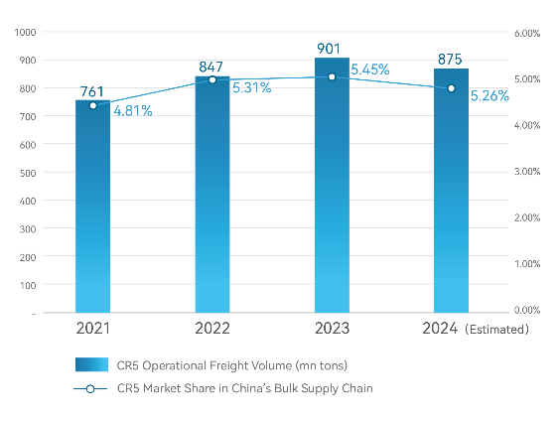 |  | 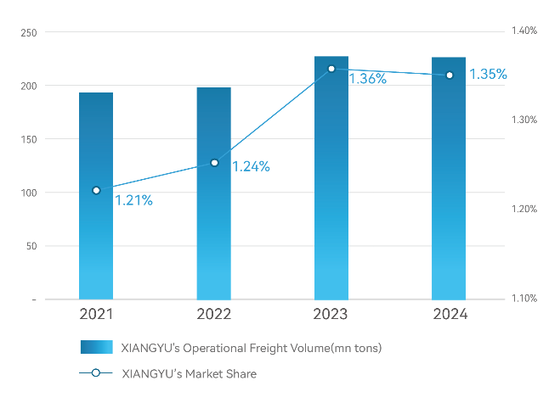
 | Figure 1：Operating Volume and Market Share of CR5 in China’s Bulk Supply Chain Industry |  | Figure 2：the Company’s Operating Volume and Market Share in China's Bulk Supply Chain Industry

- Customer Demand Evolution Drives Deeper Integrated Supply Chain Convergence
At a critical juncture where manufacturing enterprises are experiencing a shift in growth pace, structural optimization, and transformation of growth drivers, the era of high-quality development has raised the bar for supply chain services—manufacturing clients now demand greater cost efficiency and operational effectiveness. Leading supply chain players are evolving their business models, focusing on supply bundling, process integration, value chain expansion, and regional collaboration. Cross-category integration of upstream and downstream channels, along with logistics capabilities, has become a critical competitive differentiator. By leveraging the synergy between trade and logistics, top-tier supply chain companies can efficiently allocate resources by harnessing upstream and midstream channel control and networked logistics services. This enables seamless flow of multi-category product across the entire supply chain, further deepening the integrated, full-industrial-chain operating model and enhancing service advantages.
- Geopolitical Shifts Reshape Industry Security and Global Landscape
Geopolitical tensions are undermining the security of global industrial and supply chains, disrupting international economic flows and intensifying the imperative for resilient cross-border networks. In response, Chinese enterprises are accelerating the buildout of resource networks along the Belt and Road countries, and establishing regional supply chain hubs through overseas manufacturing bases. Concurrently, geopolitical conflicts are accelerating the restructuring of the global energy landscape, prompting China to expedite the development of a more robust energy security framework. These trends are expected to drive substantial demand for overseas sourcing, international logistics, cross-border e-commerce, and advisory services. Supply chain leaders with first-mover advantage in developing overseas sourcing and logistics corridors, building localized teams, and delivering integrated services are well positioned to meet rising offshore supply chain demand from Chinese enterprises and unlock incremental growth across international markets.
- Tech Breakthroughs Fuel Digital Supply Chains and Value Chain Extension
As manufacturing enterprises place increasing demands on improving the quality and efficiency of supply chains, coupled with occasional risk incidents, supply chain security has been elevated to a strategic priority, accelerating the urgency of digital and intelligent transformation across the sector. Leading players are actively advancing practical applications of digital intelligence. Having initially focused on building foundational infrastructure—such as digitized logistics facilities, secure warehouse systems, multimodal transport integration, and freight resource consolidation—they are now pivoting toward more advanced, integrated solutions, including intelligent supply chain finance, digital risk control systems, and smart industrial service platforms.
Cloud computing, big data, artificial intelligence, blockchain and other technologies are booming and gradually penetrating into the bulk supply chain service industry. These advancements will effectively improve the synergistic efficiency of each link in the bulk supply chain, enable platform-based sharing of logistics, goods, information, and capital flows, and drive the optimization and upgrading of the industrial supply chain.

III. Business Analysis During the Reporting Period
The Company specializes in bulk supply chain services, with manufacturing enterprises as its core customers. It provides comprehensive supply chain solutions covering the procurement of bulk raw and auxiliary materials, product distribution, logistics and delivery, supply chain finance, and information consulting, etc. The Company is committed to becoming a world-class supply chain service provider.
- Business Structure
In terms of product portfolio, based on customer needs and its own business philosophy, the Company applies the following product selection criteria: ①high liquidity and easy monetization; ②high standardization and easy storage; ③substantial demand with extended industrial chains that enable integrated multi-stage services. The Company currently focuses on bulk commodities including metallic minerals, agricultural products, energy and chemicals, and new energy materials, covering seven core categories: ferrous metals, aluminum, stainless steel, new energy, coal, oil, and grains.

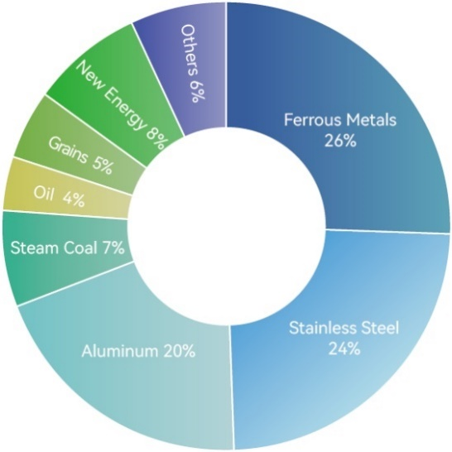
Figure 3: Breakdown of Combined Spot and Futures Gross Profit in 2024
In terms of customer structure, the ratio of Company’s service volume for manufacturing clients remains stable at over 60% in 2024. Specifically, around 80% of services are within the new energy supply chain, over 70% within the ferrous metals, coal and aluminum supply chains, and over 60% within the stainless steel, and over 50% within the grain supply chains.
In terms of regional layout, the Company has established 10 platform companies across China, expanding its business presence to cover 34 provincial-level administrative regions. Its core business area is gradually extending from coastal regions to inland areas, with a focus on tapping the supply chain demand of modernized industrial clusters in central and western China.
In recent years, the Company has strategically positioned itself along the Belt and Road Countries, actively expanding into international markets. It has established subsidiaries or representative offices in 10 countries and regions, including Singapore, the United States, Germany, Saudi Arabia, New Zealand, Indonesia, Vietnam, and South Africa. Its business partners now span more than 110 countries, with a strong focus on connecting with premium procurement and distribution channels aboard and exploring the overseas supply chain demands of large Chinese enterprises.
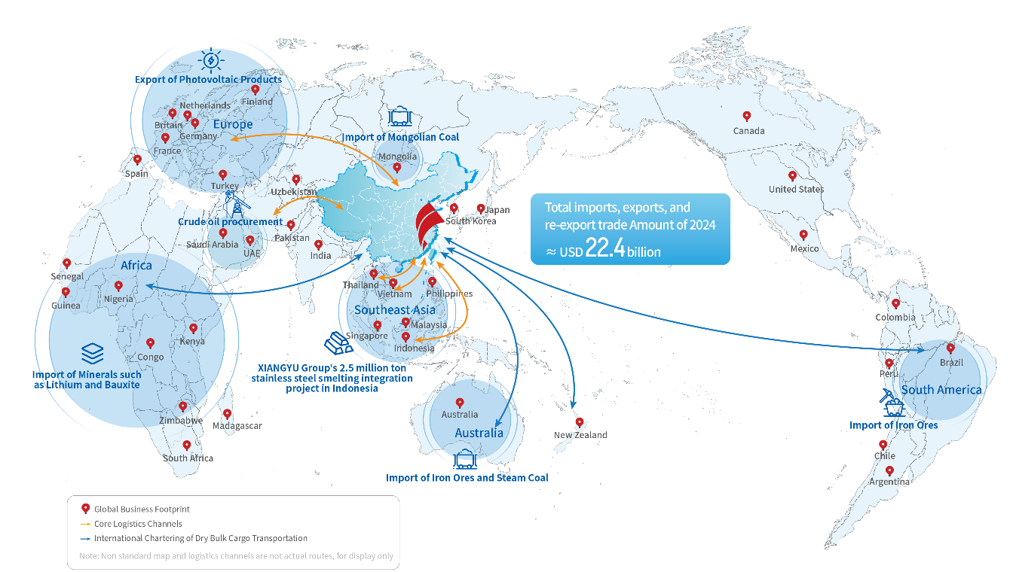
Figure 4: Company’s Global Business Footprints

- Business Model
The Company has always adhered to a customer-centric approach, extending upstream to secure resources and downstream to expand channels along the industry chain. Its service offerings have evolved from single-point solutions to an integrated “full-industry chain service model” with Xiangyu characteristics, covering raw material procurement, finished product distribution, inventory management, warehousing and logistics, supply chain finance. After achieving service advantages across the entire industry chain, the Company seized the opportunity to tap into value-adding manufacturing segments, forming an industrial chain operation model of “Supply Chain Services + Products Manufacturing”, which further enhanced comprehensive revenue profitability and buffered cyclical fluctuations.
In the era of digital intelligence, the Company has accumulated a vast array of service cases and experience data from specific business scenarios, enabling it to swiftly respond to customer needs and recommend suitable products and services. By taking advantages of its distinctive “trade-logistics linkage”, the Company integrates regional warehouses and cross-regional logistics, and, through the application of bulk commodity price management tools, provides value-added services to manufacturing clients and deliver customized supply chain solutions.
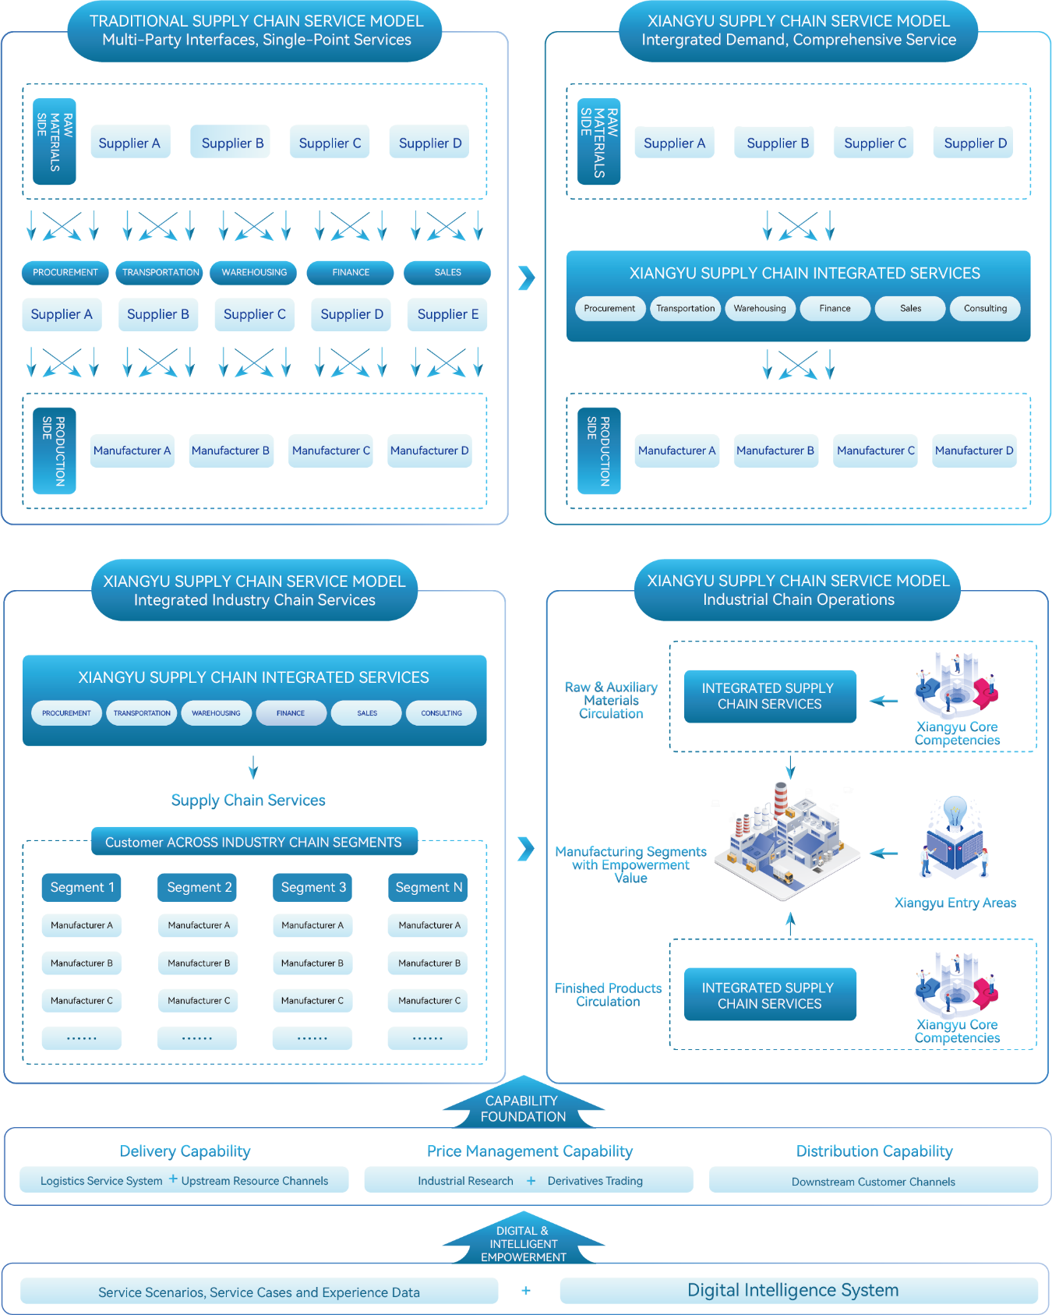
Figure 5：Company's Operating Model
- Profit Model
The Company prioritizes service and scale-driven profitability, and is supplemented by price differentials to generate profits. For a detailed breakdown of the Company’s profit, please refer to the table below.
Table 1: Profit Structure and Definitions
Types of Profit |  | Interpretation
Service Profits |  | Based on its platform advantages and scaled operations, the Company provides customers comprehensive services across the entire industry chain. These offerings encompass procurement and sales, processing, logistics and distribution, supply chain finance, and information consulting, through which the Company generates service-based revenue.
Transaction  Profits | Scale-based Profit from Cargo Consolidation | Relying on its large business scale, the Company achieves cost advantages through centralized procurement and specialized operations, reducing operational costs across various segments and generating trading gains.
Transaction  Profits | Profits  from Price Differentials | By utilizing its expertise in professional analysis, the Company conducts trades by studying commodity price trends over time and regional price differences across various areas to generate profitability.
- Strategy Overview
To support its core bulk commodity supply chain services, the Company has pioneered an industry-leading, network-based logistics system integrating “Highway, Railway, Waterway, and Warehousing” to connect both domestic and global markets. Capitalizing on industry cycles, the Company strategically tapped into manufacturing, extending its service scope and expanding its operational boundaries. Today, the Company has established three key manufacturing segments—shipbuilding, mineral processing, and oil processing. In addition, the Company has achieved deep synergy with its controlling shareholder in the manufacturing segments of the stainless steel, aluminum, and corn industry chains, further amplifying its supply chain service advantages and unlocking additional growth potential.
Adhering to the strategic vision of "Rooted in Supply Chains, Serving Industry Chains, and Creating Value Chains," the Company will expand its global supply chain network by continuously deploying strategic overseas logistics hubs; strengthen its commercial influence by making minority equity investments in upstream mining rights, securing critical resources across core industries; and integrate downstream channels to unlock end-to-end circulation and service markets.
- Global Development Landscape
Amid profound changes in the global economic landscape, the Company had harnessed its years of industry expertise and channel resource advantages to establish a global development framework featuring “Led by Supply Chain, Supported by Logistics, and Driven by Investment”.
First, the Company is building regional industrial ecosystems with global competitiveness. In Southeast Asia, it has developed a full-industry chain model featuring “Resource Importation, Advanced Processing, and Global Distribution”, supported by a localized logistics network and extending its reach across ASEAN markets. In Africa, the Company has built an integrated mineral supply chain to ensure the stable delivery of high-quality bauxite and titanium ore from West Africa. Its beneficiation plant in Nigeria has achieved a service coverage rate of over 90%, complemented by the innovative establishment of a centralized procurement laboratory. In the Democratic Republic of the Congo(DRC), its copper and cobalt services support leading new energy enterprises, enhancing both resource access and brand influence. In the Americas, the Company continues to deepen cooperation in mineral, agricultural, and energy trade, improving its regional industry presence. In the Middle East and Oceania, it cultivates high value-added product trade to support the global expansion of Chinese manufacturing. In traditional resource-rich countries like Australia, it has built stable and diversified supply channels to safeguard national energy resources.
Second, the Company is systematically advancing its global logistics capabilities. It has established major international logistics corridors, including China-Southeast Asia, China-Africa, and China-Europe/Central Asia railway express. It has developed and fully operates multiple premium routes across East, West, and Southern Africa, continuously enhancing its multimodal domestic and international transport capacity. To date, the Company has built a global logistics service network, partnered with over 200 high-quality overseas suppliers, and established more than 150 overseas warehousing nodes. It operates self-managed warehouses in key hubs such as Vietnam, the United States, and the Netherlands. Tailored logistics services have been developed for the aluminum and new energy industry chains, focusing on emerging markets like Southeast Asia and Africa, with integrated customs clearance, warehousing, and distribution services to provide comprehensive support for the global expansion of Chinese manufacturers.
Third, the Company pursues targeted overseas investment with a global perspective. In the metallic mineral segment, it aligns with national resource security strategies by investing in resource-rich regions such as Southern and Western Africa. Through equity investments and long-term agreement procurement, it has built stable overseas supply channels, including the joint venture shipping company in Guinea and the joint venture mineral company in Zimbabwe. In the new energy segment, aligned with the “dual carbon” strategy, the Company has enhanced its industrial layout in Southeast Asia and Europe, expanded photovoltaic re-export business, and promoted the internationalization of Chinese technologies and standards. In the automotive and agroforestry segments, it has cultivated its presence in Belt and Road markets and extended the value chain through localized operations in the Middle East and New Zealand.

IV. Analysis of Core Competitiveness During the Reporting Period
- Networked Logistics Service Capability
As a national 5A-level logistics enterprise, the Company has developed three key logistics operating entities (Xiangyu Superchain, Xiangdao Logistics, Xiangyu Agricultural Products), and has built a team of specialized, market-oriented, and internationally experienced logistics service professionals. Leveraging long-term strategic partnerships with key logistics resource operators such as COSCO Shipping, China Merchants Group, and Shandong Port Group, the Company has taken the lead in the establishment of networked logistics service system that centered on “Highway, Railway, Waterway, and Warehousing” connecting both domestic and international markets. This system includes a railway transportation network that connects the east and west regions and links the north and south regions, a nationwide highway transportation network, a waterway network based on major domestic ports and extending to countries along the Belt and Road Regions, and warehouse clusters covering coastal areas in the east and bulk distribution hubs in the central and western regions. It also connects to international markets through ocean shipping and cross-border freight trains, enabling the development of integrated logistics corridors and localized logistics operations overseas.
The Company fully takes advantage of multi-modal transport routes to provide customers with high-quality, end-to-end, and customized bulk commodity logistics solutions. Domestically, it has developed a number of premium routes such as “Cross-province Circulation of Aluminum Products” , “North-to-South Grain Transportation”, “West-to-East Coal Transportation”, and “North-to-South Coal Transportation”. Internationally, the Company has established international logistics corridors including the China-Europe and China-Central Asia railway express, as well as international routes such as China-Indonesia, China-Vietnam and China-Thailand, China-Africa, and China-Australia.
The networked logistics service system is not only one of the Company’s core capabilities in serving manufacturing customers, but also an important cornerstone for the Company’s cargo rights control and business digital transformation.
During the reporting period, the Company was ranked second among the Top 50 Chinese Logistics Enterprises of 2024, ranked second among the Top 100 National General Warehousing Enterprises of 2023, and recognized as “Advanced Unit in the Construction of China’s Digital Warehousing Standard System” for 2023. It was also selected as “2024 First Batch of CFLP Benchmark Cases for National Logistics Cost Reduction”.
Table 2: Logistics Resources and Capabilities
Category | Resources Capacity
Railway | The Company operates 12 railway cargo stations (10 self-owned and 2 managed), covering major commodity distribution hubs in the central and western China. These are supported by 87 dedicated railway lines, approximately 3.8 million square meters of container yards and warehouses, and over 30,000 self-owned containers. The annual transportation capacity exceeds 57 million tons, ranking among the top in the industry. The Company has also developed high-quality transportation routes for coal and aluminum products, such as“Shandong/Henan-Xinjiang” and “Shaanxi-Yunnan/Guizhou/Sichuan”. Internationally, the Company has developed round-trip circulation routes centered on the Eurasian continent, with its partnership network covering over 80% of China-Europe Railway Express platforms nationwide. It has also deployed self-owned containers to continuously enhance the operational capacity of China-Europe and China-Central Asia freight trains. In addition, the Company has taken a forward-looking approach by laying out logistics corridors across the Caspian Sea, aiming to build comprehensive international multimodal transport capabilities.
Highway | It has built a network freight transportation platform to fully leverage the value of digital freight services, enhance vehicle-cargo matching efficiency, enable real-time transportation tracking, and achieve end-to-end transparent management from shippers to carriers, thereby boosting quality and efficiency across the supply chain. During the reporting period, the Company operated approximately 1,000 self-owned vehicles and integrated more than 160,000 third-party vehicles, achieving a total freight volume of over 23 million tons.
Waterway | Domestically, the Company owns 3 multi-purpose domestic vessels and integrates over 1,200 social vessels, forming a “self-owned + partnership” water transport capacity configuration. It has formed strategic partnerships with leading port and shipping operators such as China Merchants Port Group, Shandong Port Group, COSCO SHIPPING Ports, and Tianjin Port Group. During the reporting period, the Company’s domestic coastal and Yangtze River transportation volume exceeded 25 million tons. Overseas, the Company owns 2 vessels and continues to integrate international collection and distribution shipping resources, building capabilities in international dry bulk and container shipping logistics. During the reporting period, the China-Indonesia logistics corridor cargo volume was approximately 26 million tons, achieving a 50% year-on-year increase; the China-Africa logistics corridor exceeded 3 million tons, achieving a 270% year-on-year increase; theChina-Vietnam and China-Thailand logistics corridor handled 36,000 TEU, achieving a 20% year-on-year increase; and the China-Australia logistics corridor transported over 2 million tons, establishing stable route operation capabilities.
Warehousing | Domestically, the Company has established 5 major grain procurement platforms with its own and partnered storage capacity of approximately 12 million tons, equipped with 20 dedicated railway lines. It operates 69 self-owned and leased warehouses, covering an area of over 1.6 million square meters, and has 8 stacking yards with an area of over 500,000 square meters. The Company holds 20 approved futures delivery licenses, with a warehouse capacity of about 1 million tons. Overseas, the company maintains a regular inventory of 50 storage nodes, with forward-looking strategic layouts in more than 150 locations, covering Southeast Asia, Africa, Central Asia, the Middle East, and Europe. It has also launched self-operated overseas warehouse businesses in key logistics hubs such as Vietnam, the United States, and the Netherlands, establishing comprehensive logistics service capabilities abroad.

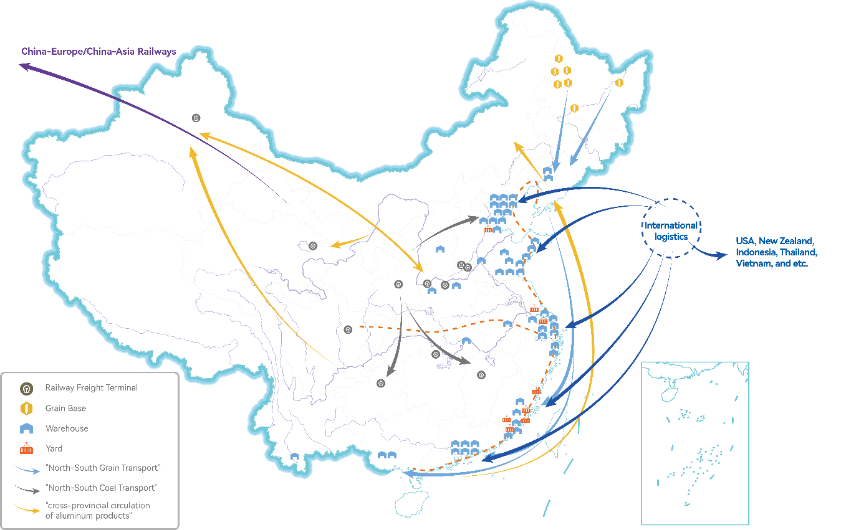
Figure 6: Company's Nationwide and International Networked Logistics Service Ecosystem
- Digitalized Supply Chain Service Capability
The Company focuses on three core goals: expanding incremental markets, improving service efficiency, and elevating business model. Leveraging vast business data, extensive customer resources, and diverse application scenarios, it has built an intelligent information technology system. Based on its smart logistics system, the Company continues to enhance its digital service capabilities and has developed the YuLianTong digital supply chain service platform, facilitating efficient matching between capital providers and customer demands. During the reporting period, the YuLianTong platform reached a total credit line of RMB 13.7 billion, with annual credit utilization by customers amounting to approximately RMB 3.6 billion, representing a year-on-year growth of over 30%.
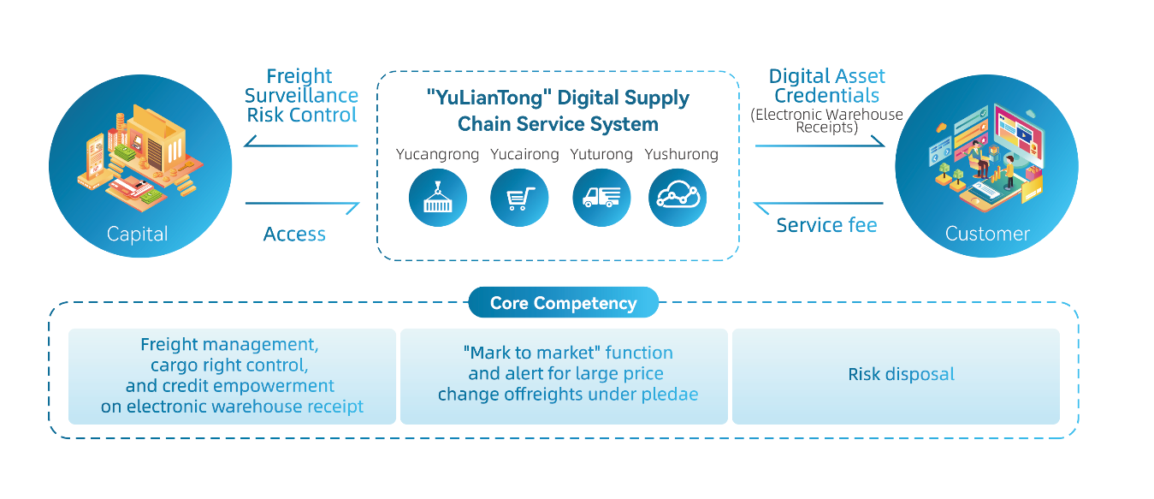
Figure 7: YuLianTong Digital Supply Chain Service System
Furthermore, the Company has established an integrated system that covers modules like financial control, human resources management, customer relations, risk management, and equipment & asset management, providing comprehensive support for business operations. Through enterprise management analysis systems, customer analysis, and big data operation systems, the Company sorts, extracts, and mines extensive business data to support business decision-making. Currently, the Company's core information system is integrated with the DeepSeek Large Language Model, marking the official beginning of a new phase in the integration of “AI + Industry”. This empowers the development of new productive forces through artificial intelligence, injecting new momentum into the Company's and the industry’s high-quality development.
- Systematic Risk Management Capability
The Company firmly grasps the foundations of risk control by targeting manufacturing enterprises as its core clients and focusing on highly liquid, easily convertible, standardized, and storable bulk commodities as its main products. It adapts the composition of these products dynamically based on industry cycle changes to strengthen its ability to hedge against cyclicality.
The Company has always maintained a reverent attitude towards the market, prioritizing risk control over profit and scale. It has currently established three lines of defense for operational risk (i.e. frontline business departments, headquarters risk control departments, and headquarters audit departments). It implements a multi-departmental joint, collective prevention and control mechanism, around the establishment of pre-control management systems, in-process management, post-event review, and system optimization.
- Global Channel and Resource Integration Capability
The Company has cultivated a strong customer base comprising top-tier enterprises in industries such as metal minerals, agricultural products, energy and chemicals, and new energy, establishing a mature and stable global business network. Through close collaboration with customers from upstream and downstream at home and abroad, fund providers, technology support providers, and logistics service providers, the Company integrates abundant industry resources, information resources, logistics resources, and financial resources to provide customers with integrated supply chain solutions. As a result, the Company's resource advantages are increasingly strengthened, its business model is becoming more mature, and its upstream bargaining power, downstream distribution capabilities, and comprehensive supply chain service capabilities are continuously enhanced.
- Multidimensional Industry Research Capability
The Company has established a three-tier research framework consisting of Research Institute at the Group Headquarters, Industry Research Department of the Corporation and Research Departments within front-line operating entities. It boasts a team of dedicated researchers with an international perspective, conducting research across macroeconomic, industry, product, business development, and risk management dimensions. This enables continuous iteration of research methodologies across various industry chains. The Company has also built comprehensive supply chain databases encompassing operations, finance, logistics, risk management, and human resources, accumulating vast amounts of data. Meanwhile, it strengthens the collaborative synergy between industry research and front-line business and operations management, empowering the Company's business operations, risk control, and business model upgrading, and contributing to the Company's high-quality development.
- Specialized Supply Chain Service Team
The Company places a strong emphasis on talent development and team building, cultivating a market-driven, specialized, and globally-oriented supply chain service team which could provide professional supply chain solutions tailored to customer needs. Meanwhile, the Company consistently enhances its international human resources system through a dual strategy of external recruitment and internal training, cultivating an elite talent pool with an international perspective and service expertise, with services covering regions such as Southeast Asia, Africa, Europe, and the United States. Additionally, the Company’s team management and performance evaluation mechanisms are highly market-oriented, with continuous innovation in incentive programs, effectively motivating core management and front-line business teams to demonstrate initiative, proactivity, and creativity.

V. Management Discussion and Analysis of Business Operation
- Key Operating Results for 2024
In 2024, China’s economy demonstrated overall stability with progress, but the adverse effects of external environmental changes continued to deepen. The procurement demand from downstream manufacturing customers remained weak, and commodity prices faced pressure. In response to market fluctuations, the Company has remained committed to its platformization, globalization, and digitalization strategies, taking its advantages of resource integration and trade-logistics linkage. The Company has also drawn valuable lessons from past experiences to optimize and adjust its organizational structure, management practices, and operational strategies. These efforts have further strengthened the foundation for sustainable development, leading to overall business stabilization and improvement. During the reporting period, the Company reported revenue of RMB 366.671billion, representing a year-on-year decrease of 20.12%; net profit attributable to the parent company reported RMB 1.419 billion, a year-on-year decrease of 9.86%. Excluding the impact of credit impairment losses, the net profit attributable to the parent company increased by over 7% year-on-year, signaling the initial positive results of the management optimization efforts.
The Company’s platform-driven momentum has steadily advanced. During the reporting period, the total operating volume remained above 200 million tons, with aluminum, new energy materials, and Mongolian coal maintaining leading market shares; the trading volumes of lithium and iron ore increased by over 160% and 20% year-on-year, respectively, further strengthening the Company’s industry position and resource network advantages; the agricultural supply chain segment returned to positive gross margins on spot and futures operations; the shipbuilding segment saw record highs in both new order volume and order profitability, contributing stable and sustainable profits to the Company. In addition, the Company established a Steel Center by integrating its ferrous metals supply chain, coordinating internal and external resources to build a comprehensive operational management system. Through deeper integration across Trade-Logistics, Trade-Trade, and Trade-Manufacturing models, the Company is addressing clients’ diverse service needs, improving operational efficiency, and enhancing customer loyalty—exploring the optimal path for specialized and intensive development.
The Company has achieved significant breakthroughs in international expansion, with its global business now covering over 110 countries. During the reporting period, the Company recorded a total import, export and re-export volume of approximately USD 22.4 billion, with import and export volume totaled approximately USD 14.4 billion. The total trade volume with BRICS countries, Belt and Road regions, and countries in South America and Africa grew by over 50% year-on-year, with exports increasing by over 60%. The Company continued to strengthen its international logistics channel advantages: The China-Indonesia corridor recorded a year-on-year cargo volume increase of over 50%, maintaining a leading market share; the China-Vietnam and China-Thailand corridor achieved growth of over 20%; and the China-Africa corridors surged by 270%. The specialized logistics volume in the aluminum industry chain grew against the trend by over 45%. Additionally, the Company entered into a strategic partnership with a leading bauxite mine in West Africa to establish a joint venture shipping company. This collaboration will leverage the partner's cargo volume to build owned capacity for the West Africa-China route, enhancing the Company’s aluminum supply chain layout. Furthermore, in early 2025, the Company established a subsidiary in South Africa, accelerating business expansion in Africa through the integration of logistics and trade. Due to the synergy between trade and logistics, the Company’s aluminum and new energy supply chains have taken the lead in setting a practical benchmark for international full-industry chain services, paving the way for scaling up its global integrated supply chain service capabilities with proven models and experiences.
The Company’s digitalization and intelligence-driven capabilities have become increasingly prominent. The YuLianTong platform has further expanded its product matrix and specialized scenarios. Leveraging transaction data accumulated from years of supply chain services, the platform has introduced the new YuShuRong sub-product, effectively enhancing downstream customers’ access to banking finance and improving efficiency, which boosts increasing customer loyalty in turn. The ZhiYun network freight platform collaborated with the merchandise operation and logistics teams to jointly develop large industrial clients, unlocking the value of digital freight, deeply integrating capacity resources, and empowering business operations. Additionally, the LiangLianTong platform has introduced new products such as MaiLiangBao and AnXinCun, which improve banking financing efficiency for customers in planting, procurement, and storage, while utilizing derivative tools to help customers manage pricing risks.
After two years of exploration and adjustments, the Company has further emphasized "Product & Research First" in strategic approach, "Logistics First" for international expansion, and "Risk Control First" in business management. The business model, centered on serving manufacturing clients, has demonstrated strong self-repair capabilities and development resilience. In 2024, the Company’s business fundamentals continued to stabilize and improve. It swiftly responded to and mitigated the risks from a key customer incident in the second half of the year, quickly summarizing lessons learned and strengthening the risk control system. This included: (1) steadily advancing the construction of digital and intelligent risk control, (2) revising and improving the industry research and risk alert system, and (3) gradually phasing out inefficient and high-risk businesses. During the reporting period, the Company optimized and improved its customer structure and business composition, increased the proportion of service revenue, and enhanced its ability to achieve win-win cooperation with upstream and downstream partners by using derivative tools. As a result, the Company’s business stability and growth resilience have been further strengthened.
With the government rolling out proactive policies to boost domestic demand, stabilize expectations, and stimulate vitality, the economy is poised for a sustained recovery. The Company is confident in its ability to overcome development bottlenecks and strengthen the foundation for sustainable growth, despite industry cyclical fluctuations. Taking the preparation and implementation of its next five-year strategic plan as an opportunity, the Company aims to return to the path of high-quality development.
- Key Business Data for 2024
- Bulk Commodity Trading
The Company leverages bulk commodities as its core business, entering into comprehensive agreements with clients to offer integrated supply chain services encompassing procurement, distribution, logistics, supply chain finance, information consulting, and processing. The revenue and profitability from this segment are reflected in the results of core commodity trading, as outlined below:
Unit: billion, RMB
Category | Operating Volume |  | Operating Revenue |  | Combined Futures and  Spot Gross Profit |  | Combined Futures and Spot  Gross Profit Margin
Category | Volume  (mn metric tons) | YOY | Amount | YOY | Amount | YOY | Value | YOY
Commodity Trading | 224.48 | -0.30% | 345.3 | -21.39% | 6.318 | 2.85% | 1.83% | Increase by 0.43 ppt
Among these:  Metallic Mineral | 139.84 | 6.53% | 214.9 | -20.84% | 4.538 | -12.34% | 2.11% | Increase by 0.20ppt
Agricultural Products | 13.90 | -31.71% | 40.2 | -33.73% | 0.382 | Turned  profitable | 0.95% | Turned profitable
Energy and Chemical | 70.20 | -4.05% | 80.1 | -7.78% | 0.839 | -20.07% | 1.05% | Decrease by 0.16 ppt
New Energy | 0.54 | 47.03% | 9.3 | -51.92% | 0.499 | 45.85% | 5.39% | Increase by 3.62ppt
Note: The Company provides integrated supply chain services and engages in spot trading to support its operations. It utilizes futures instruments to hedge against price volatility in the commodity markets, resulting in changes in fair value and gains or losses from the disposal of such instruments. The combined gross profit and gross profit margin of the futures and spot trading are calculated after accounting for the hedging gains or losses.
In the metallic mineral supply chain, the Company maintained its competitive advantage in Mongolian coal imports and expanded its presence in bauxite and ferrochrome resources across Africa and Southeast Asia, as well as in steel markets in the Middle East, Africa, and South America, with ferrochrome imports volume increased by over 30% year-on-year, while steel exports surged by more than 150%. Gross profit margin of the aluminum supply chain (spot and futures combined) rose significantly by 1.12 percentage points year-on-year. However, due to subdued demand and declining prices in the ferrous and stainless steel industrial chains, both revenue and gross profit declined year-on-year.
In the agricultural supply chain, the Company strengthened flow management and inventory rotation, expanded service-oriented and import businesses, enriched the LiangLianTong product system, and enhanced asset turnover efficiency and warehouse utilization. Against the backdrop of continued price decline in bulk grain commodities, the segment successfully turned profitable at the gross margins on spot and futures operations level and maintained a steady upward trend in business performance.
In the energy and chemical supply chain, the Company increased the proportion of direct coal mine procurement, explored new crude oil supply channels, and achieved steady growth in overseas business volume along the oil industry chain. Nevertheless, due to weaker demand and falling price centers in the steam coal and oil segments, both revenue and gross profit decreased year-on-year.
In the new energy supply chain, the Company strengthened upstream access to critical lithium resources both domestically and internationally, deepened collaboration with leading lithium salt processors midstream, and acquired new terminal clients at home and abroad downstream. As a result, both business volume and profitability achieved significant year-on-year growth. However, overall revenue declined due to the drop in commodity prices.
- Bulk Commodity Logistics
While meeting the internal logistics needs of its supply chain operations, the Company has also leveraged its internal business foundation to develop market-oriented logistics service capabilities, which in turn feed back into and empower its supply chain operation, creating a mutually reinforcing cycle between commodity operations and logistics services. In parallel, the Company is building dual capabilities: the ability to provide integrated industrial logistics solutions across the value chain, and the execution expertise to deploy these solutions operationally. This approach has accelerated the formation of a logistics system in which industrial resources and logistics services drive and enhance one another. The operating results of the Company’s market-oriented logistics services are accounted for separately, as outlined below:
Unit: million, RMB
Category | Operating Revenue |  | Gross Profit |  | Gross Profit Margin
Category | Amount | YOY | Amount | YOY | Value | YOY
Commodity Logistics | 9,422 | 32.99% | 837 | 19.03% | 8.88% | Decrease by 1.04 ppt
Among these: Integrated Logistics | 6,171 | 11.38% | 661 | 20.11% | 10.71% | Increase by 0.78 ppt
Railway Logistics | 2,845 | 126.90% | 132 | 158.45% | 4.64% | Increase by 0.57 ppt
Agricultural Product Logistics | 249 | -14.14% | 32 | -68.70% | 12.82% | Decrease by 22.34 ppt
Aluminum Industry Logistics | 157 | Not applicable | 12 | Not applicable | 7.95% | Not applicable
Note: Railway logistics, agricultural logistics, and aluminum industry logistics refer respectively to the market-oriented logistics services provided by the Company’s subsidiaries Xiangdao Logistics, Xiangyu Agricultural Products, and Xiangyu Aluminum Union. Integrated logistics refers to the market-oriented logistics services offered by Xiangyu Superchain and other logistics subsidiaries. Specifically, agricultural logistics mainly covers services related to national and provincial grain reserves, while aluminum industry logistics and integrated logistics primarily include international shipping routes, cross-border rail freight services, inland waterway transport, highway transportation, and warehousing services both domestically and overseas.
Integrated Logistics: The Company deepened partnerships with industrial clients and expanded its warehousing network. It newly obtained three futures delivery qualifications, establishing a delivery warehouse system covering 15 types of commodities across its four major business segments. Meanwhile, the Company drove significant growth in both domestic north-south logistics corridors and international routes to Southeast Asia and Africa. It also consolidated its market share advantage on the China-Indonesia route and developed premium services for Asia-Europe railway express, resulting in year-on-year growth in both revenue and gross profit.
Railway Logistics: The Company strengthened its presence in the coal and aluminum industrial chains, achieving a substantial increase in Xinjiang Coal Outbound Transportation. It also it expanded rail-to-port bauxite logistics, as well as logistics services for lithium ore, lithium carbonate, and other new energy industry materials, accelerating the deployment of high-quality, capital-light hubs and improving turnover efficiency of self-owned containers, which drove year-on-year growth in both revenue and gross profit.
Agricultural Logistics: Due to reduced volumes from national reserve, falling corn prices, inverted price differentials between northern and southern regions, and cautious downstream procurement, and cargo volumes decreased, leading to year-on-year declines in both revenue and gross profit. However, by capitalizing on reserve replenishment opportunities in Fujian and Guangdong provinces and centrally administered warehouses, the Company expanded third-party storage volumes and successfully launched the innovative “CunLiangBao + AnXinCun” product system. As a result, combined volumes across four key categories—provincial reserves, temporary reserves, third-party reserves, and CunLiangBao—achieved a 37% year-on-year increase.
Aluminum Logistics: In September 2023, the Company established Xiangyu Aluminum Union, a specialized subsidiary dedicated to aluminum logistics. Leveraging its existing logistics infrastructure and customer base, and underpinned by a comprehensive domestic multi-modal network (Highway, Railway, Waterway, and Warehousing), the Company focused on building an end-to-end international logistics corridor from overseas mines to domestic distribution hubs, accelerating the development of specialized logistics capabilities for the aluminum supply chain. During the reporting period, it prioritized serving major aluminum producers and developed premium logistics routes both at home and abroad, reaching a service volume of 3.38 million tons.
- Production & Manufacturing
After establishing a service advantage throughout the industry chain, the Company strategically ventured into the value-added production and manufacturing sector. This move resulted in the development of an integrated industrial chain operating model that combines supply chain services with production and manufacturing, the objective is to enhance overall profitability and mitigate the impact of cyclical fluctuations in the industry. The operating results in the manufacturing segment for this period are as follows:
Unit: billion, RMB
Category | Operating Revenue |  | Gross Profit |  | Gross Profit Margin
Category | Amount | YOY | Amount | YOY | Value | YOY
Production & Manufacturing | 11.1 | 2.54% | 1.292 | -1.86% | 11.60% | Decrease by 0.52 ppt
Among these: Shipbuilding | 5.9 | 24.76% | 1.072 | 0.27% | 18.13% | Decrease by 4.43 ppt
Note:
- The manufacturing segment includes shipbuilding, beneficiation and oil processing. The business entity of shipbuilding sector is the Company's subsidiary, Nantong Xiangyu Shipbuilding & Offshore Engineering. During the reporting period, the Company increased its ownership stake in Xiangyu Marine Equipment from 36% to 51%.
- In the shipbuilding segment, exchange rate fluctuations of the U.S. dollar led to a decline in reported gross profit margin. However, by using financial instruments to hedge against foreign exchange risks, the Company achieved a year-on-year increase in actual hedged gross profit margin.
In the shipbuilding segment, the Company seized market opportunities and persistently prioritizes brand leadership. Both the number of delivered ships and new orders, along with the order margin, reached new highs. The Ultramax series bulk carriers had the largest order volume globally, while the order volume for chemical tankers under 10,000 tons ranked first worldwide. By the end of the reporting period, the order book totaled 89 ships, with orders scheduled for delivery until 2029. At the same time, the shipbuilding segment promoted lean production and technological upgrades, reducing production costs and shortening construction cycles, resulting in an overall increase in production capacity by more than 25%. In August 2024, the Company acquired the core assets of Jiangsu Hongqiang Marine Heavy Industry Co., Ltd. through judicial auction, with production expected to resume by mid-2025. Upon resumption of production, it is expected to further enhance the overall capacity of the shipbuilding segment by 40-50%.
- Trade-Logistics Linkage: Exploring a Practical Benchmark for International Full-Industry Chain Services
Against the backdrop of global supply chain restructuring, the Company has been actively exploring differentiated development paths in international markets for years. It strategically targets industries with complex supply chain structures and high demand for supply chain services, focusing on product categories characterized by supply-demand mismatches, geographically dispersed production chains, and high logistics cost ratios. By cultivating resource-rich regions with underdeveloped infrastructure through its “Logistics First” overseas expansion strategy, the Company has built a first-mover advantage to capture structural opportunities arising from the regionalization of global supply chains.
Although Africa holds abundant mineral reserves, its logistics infrastructure remains relatively underdeveloped, with certain types of mineral resources dispersed across different regions. The Company has targeted Africa as a strategic beachhead market, establishing a local subsidiary to provide integrated logistics solutions and develop industrialized international routes, with initial breakthroughs achieved in the aluminum and new energy supply chains.
- Global Integrated Aluminum Supply Chain Services
China's bauxite supply has maintained an import dependency rate exceeding 60% over the past three years. While Africa holds nearly 25% of the global reserves, the region has long experienced low development rates and inadequate logistics infrastructure—creating strong demand for international logistics services and offering substantial market potential.
In 2022, the Company established an international aluminum supply chain team and has since developed a comprehensive global service system across the entire value chain by strategically deploying key logistics nodes and industrial resources. Upstream, it built Guinea-centric bauxite import channels by leveraging trade-logistics integration; midstream, it entered industrial operations through deep cooperation with its parent company's electrolytic aluminum plants; downstream, it offered integrated export services while building a recycled aluminum circular system to extend full-chain circulation capabilities. The Company has gradually constructed three core competitive moats: upstream resource integration, trade-logistics synergy, and full-chain industrial operation. In 2024, the bauxite trading volume exceeded 10 million tons, including over 7.4 million tons imported from Africa, and alumina trading volume reached nearly 7 million tons, securing a top-three market position in China.
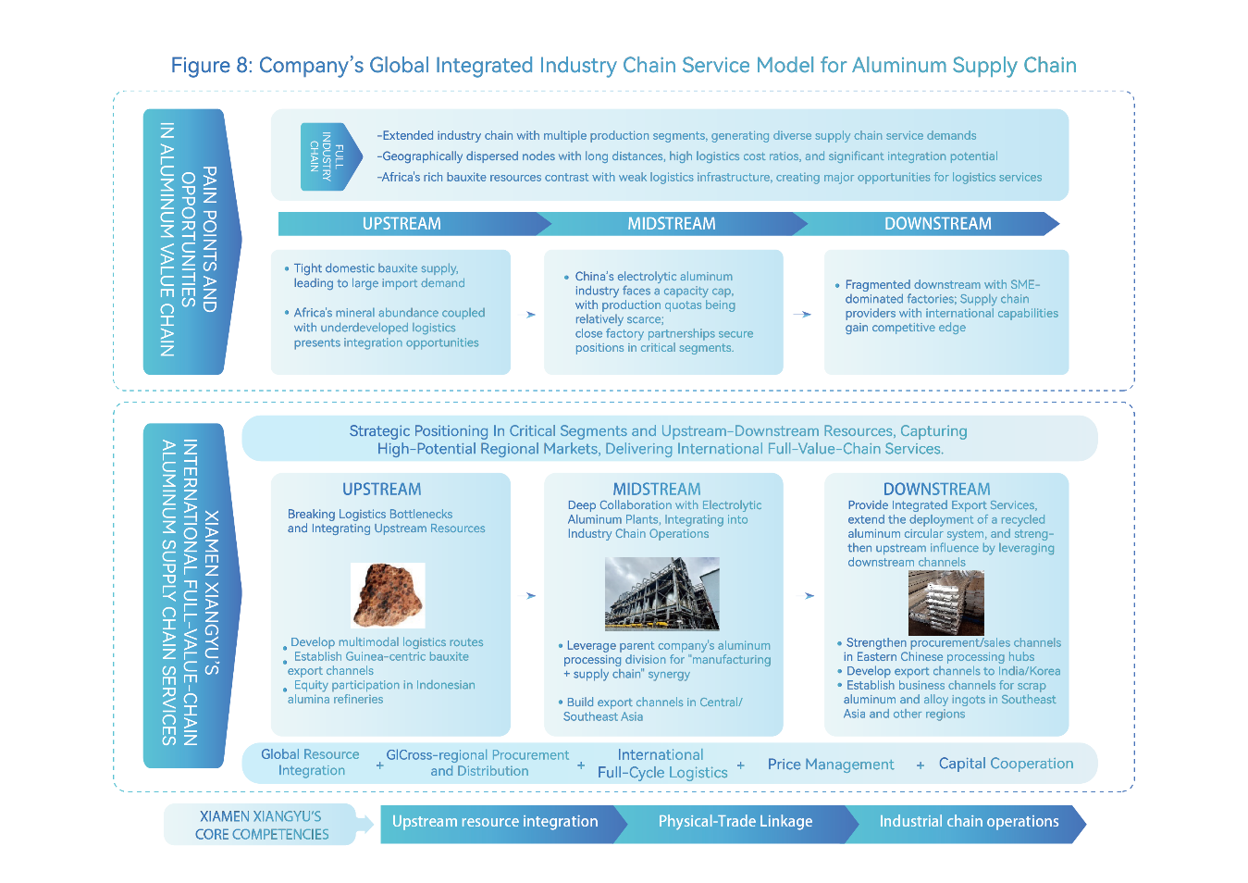
Figure 8: Company’s Global Integrated Industry Chain Service Model for Aluminum Supply Chain
At the end of 2024, the Company’s controlling shareholder obtained management rights over the core aluminum assets acquired through bankruptcy reorganization and established Xiangyu Aluminum as a new operating entity. Xiangyu Aluminum has an annual production capacity of 750,000 tons of electrolytic aluminum, 1 million tons of aluminum extrusion, and 1.8 million tons of aluminum rolling, and has also made forward-looking investments in aluminum fine processing. Depending on business synergy with Xiangyu Aluminum, the Company is set to build a competitive industry chain model integrating “Manufacturing + Supply Chain Services”, further strengthening the stability of upstream and downstream channels and enhancing its market presence.
- Global Integrated New Energy Supply Chain Services
Benefiting from the rapid development of the new energy industry chain, China's lithium ore imports have achieved a compound annual growth rate (CAGR) of approximately 25% over the past five years, reflecting strong market demand. On the international front, although Africa holds abundant reserves of new energy minerals such as lithium, cobalt, and copper, these resources are geographically dispersed, development remains in early stages, and logistics infrastructure is relatively underdeveloped—creating significant market potential and opportunities for supply chain and logistics integration.
Since 2018, the Company has strategically positioned in new energy supply chains. It has established a presence across three major segments—lithium batteries, photovoltaics, and energy storage—while concentrating on core commodities such as lithium, cobalt, nickel, silicon wafers, battery cells, modules, and energy storage systems. By integrating the full industry chain—from raw material mines and upstream smelters to midstream processors and downstream end-users, the Company has established both domestic and international procurement and sales channels across the entire industry chain, providing end-to-end logistics solutions. It has built an integrated international supply chain service capability. Currently, the Company has successfully established comprehensive partnerships with key players across major lithium production regions, including salt lakes and mines in Africa, Australia, and Jiangxi, China, as well as with battery recycling companies and leading global and domestic manufacturers of batteries and cathode materials. The Company ranks among the top five in China for lithium carbonate trading volume. In 2024, the gross profit from spot and futures operations in the new energy supply chain grew by over 45% year-on-year, with trading volumes of lithium ore and lithium carbonate increasing by more than 160% and 400%, respectively.
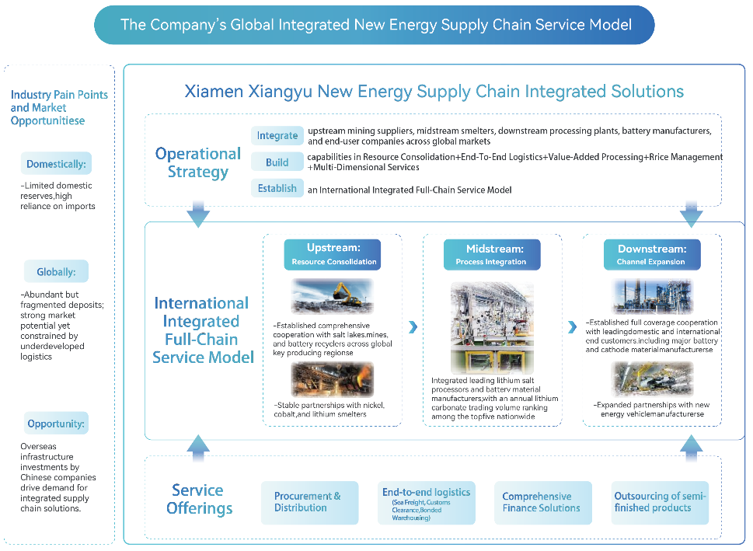
Figure 9: The Company’s Global Integrated New Energy Supply Chain Service Model
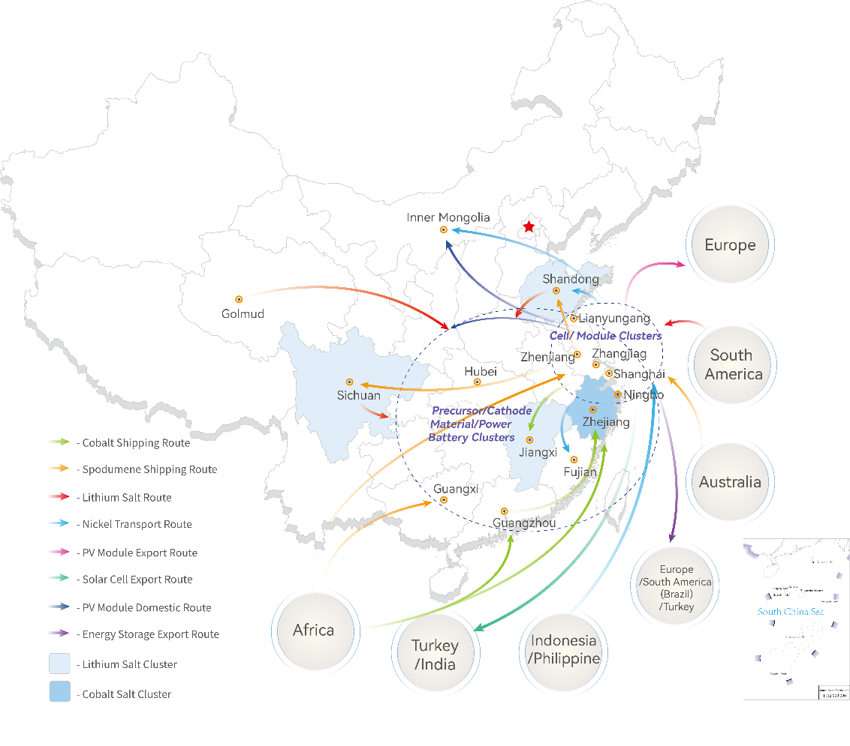
Figure 10: Global Footprint of the Company's Integrated New Energy Supply Chain Services
Building on its strong presence in the lithium battery, photovoltaic, and energy storage sectors, the Company entered the clean energy sector in 2024 to capitalize on the growing market opportunities driven by the green energy transition. By integrating its new energy supply chain capabilities with its established customer base in various industries, the Company has partnered with central power generation groups and local energy corporations to advance the development of Wind-Solar-Storage Power Plant projects, offering comprehensive low-carbon energy solutions for factories.
- Key Business Plans for 2025
In 2025, while China’s economic development continues to face a complex and challenging external environment, the nation’s long-term upward trajectory of the economy will remain unchanged. As the government adopts more proactive and effective macroeconomic policies, China’s economic will forge ahead steadily through the waves. The Company will fully leverage the lessons learned from the past two years, comprehensively refine its business strategies, risk management, and organizational structure to accelerate its recovery from the current performance downturn. Meanwhile, the Company will take the preparation of its next five-year strategic development plan as a pivotal opportunity to thoroughly review past management shortcomings, deeply analyze the phase-specific characteristics of the new era, adapt to economic development trends, clarify its strategic positioning and core competitive strengths in industry chain operations, intensify transformation efforts, and drive innovation, ultimately shaping a new blueprint for sustainable development.
Faced with the significant market shift caused by the recent U.S. imposition of “reciprocal tariffs”, the Company promptly developed a response plan. Although the Company’s business exposure to the U.S. is relatively low and its current operations have not been severely impacted, we will continue to explore diversified markets and global resource channels to mitigate the operational risks brought by international trade frictions.
In 2025, following the completion of the price-locked private placement refinancing, the Company will actively promote strategic collaboration with two powerful strategic investors, China Merchants Group and Shandong Port, and focus on the following key areas:
Platformization: Building on our industry-leading, network-based multimodal logistics system—which connects domestic and international markets via highway, railway, waterway, and warehousing—we will enhance our specialized operational capabilities across core industrial chains. We will also deepen synergies with the controlling shareholder’s manufacturing segments, including aluminum, stainless steel, and corn processing. Specifically, efforts will focus on strengthening the Company’s end-to-end international supply chain service capabilities in aluminum and new energy sectors, managing agricultural inventory exposure, scaling up service-oriented operations, leveraging the operational efficiency of the Steel Center platform, and actively seizing opportunities from the global energy transition, exploring emerging areas such as carbon trading.
International Expansion: We will accelerate the construction of China-Africa international logistics channels and establish a multi-modal, comprehensive logistics network with Xiangyu characteristics, integrating logistics and trade operations to drive global expansion. Relying on its overseas platform companies, we will solidify our competitive presence in Southeast Asia, Africa, and South America. By adopting a capital-light expansion model that exchanges equity for commercial rights, we will expedite access to mineral and primary processed resources in Africa and Southeast Asia.
Digitalization: We will promote broader application of the YuLianTong digital supply chain service platform and the ZhiYun network freight platform, along with agricultural industrial-level internet platforms and smart logistics systems that provide more tailored and comprehensive service solutions based on customer needs. We will also enhance the intelligent digital operation and management system, and explore the deep integration of AI-powered solutions with supply chain operations.
Organizational Optimization and Capability Enhancement: We will further advance the integration of our business segments taking the Steel Center as a benchmark. We will optimize the allocation of resources such as capital and human talent, improve the alignment between capital utilization and operating efficiency, and guide product portfolio optimization. We will also strengthen capabilities in industry research, risk management, and the integration of derivatives into supply chain services. Additionally, we will improve the performance evaluation and incentive mechanisms, launching a new round of equity incentive plans to stimulate team initiative and innovation.
Manufacturing: In the shipbuilding segment, we will seize the cyclical upturn in the shipbuilding market, focusing on both “capacity expansion and enhancement” and “product transformation and renewal”; accurately capture orders in alignment with medium- and long-term market trends, while enriching the ship types based on industry demand. In the beneficiation segment, we will focus on developing high-quality overseas mines and exploring deeper engagement with key clients; by strengthening collaboration with steel mills across all dimensions and delivering customized products, we aim to enhance customer stickiness. In the oil processing segment, we will continue to pursue partnerships with premium crushing plants and accelerate the integration of crushing capacity layout, driving the expansion of the soybean supply chain business.

VI. Discussion and Analysis on the Company’s Future Development
- Industry Landscape and Trends
In December 2024, the Central Economic Work Conference conducted a thorough analysis of the current economic landscape, affirming that China’s economy long-term positive trajectory remains unchanged. During the 2025 “Two Sessions” in March, the Government Work Report highlighted China’s distinctive institutional advantages, including its supersized domestic market etc. It also made clear that more proactive and effective macroeconomic policies will be implemented to expand domestic demand and promote sustained economic recovery and growth.
Despite operating in a complex and volatile external environment that has impacted business performance, the bulk commodity supply chain industry faces both challenges and opportunities. In the context of structural changes across the industrial chain, increasing market concentration is creating new business prospects. Leading bulk supply chain companies, through global network expansion and full-chain resource integration, are poised to seize strategic advantages, accelerate the growth of both domestic and international market share, and expedite the restructuring of the industry landscape.
For a detailed analysis of industry operations and development trends, please refer to “Industry Analysis During the Reporting Period”.
- Development Strategy of the Company
The Company adheres to the business philosophy of “Rooted in the Supply Chain, Serving the Industrial Chain, Creating the Value Chain”, focusing on core industrial chains and key customers. It continues to strengthen its integrated supply chain service capabilities, and deepen service value. By helping real economy enterprises reduce costs and improve efficiency, ultimately fostering mutual growth with upstream and downstream partners.
Under its Sixth Five-Year Strategic Plan, the Company adopts “Platformization, Globalization, and Digitalization” as its strategic direction, focusing on enhancing capabilities in procurement and sales services, logistics services, and information services, and on unleashing platform potential while stimulating team vitality. The Company pursues scalable growth and consistent quality improvements through expanding product categories, developing regional markets, and providing value-added services, advancing steadily toward its vision of becoming a “world-class supply chain service provider”.
The year 2025 marks both the conclusion of the Sixth Five-Year Plan and the launch of the Seventh. Leveraging the preparation of its next five-year strategic development plan as a pivotal opportunity, the Company will conduct an in-depth analysis of the phase-specific characteristics in the new era, adapt to macroeconomic trends, clarify its strategic positioning and core competitiveness in supply chain operations, and intensify efforts in transformation and innovation, mapping out a new blueprint for sustainable development.
- Business Plan of the Company
For details, please refer to “4. Key Business Plans for 2025” in “Management Discussion and Analysis of Business Operation”.
- Potential Risks
- Macroeconomic Uncertainty and Commodity Price Volatility
The world is undergoing accelerated changes unseen in a century, with an increasingly complex and challenging external environment. Rising unilateralism and protectionism, setbacks in multilateral trade systems, growing tariff barriers, combined with ongoing geopolitical tensions—pose multiple risks to global industrial and supply chains. The international commodity market is experiencing significant price volatility. As the Company's industry is closely tied to macroeconomic conditions both at home and abroad, fluctuations in the macroeconomy may have a certain impact on the Company’s operating performance.
Response Strategies: The Company actively monitors macroeconomic developments and industry trends, maintains comprehensive oversight of market risks associated with key commodities, and strengthens its analysis of price movements. By utilizing tools such as spot-futures integration and hedging strategies, the Company is enhancing its ability to proactively manage price risks.
- Operational Management Risks
While the long-term positive trajectory of China’s economy remains unchanged, the foundation of current recovery is not yet solid. Weak demand along with operational difficulties faced by certain enterprises, pose significant challenges across the industrial value chain. Consequently, the Company faces operational risks in customer credit management, business models, price fluctuations, and cargo rights control.
Response Strategies: The Company will enhance its intelligent and digitalized operational management system and further strengthen the separation of “three rights”—namely, the rights to business operations, financial management, and logistics and cargo management. A multi-pronged approach will be adopted to manage risks effectively, including: increasing the proportion of manufacturing clients while reducing customer concentration (from a customer perspective); optimizing the product mix (from a commodity perspective); upgrading business models (from a model perspective); and enhancing the risk management framework (from a control perspective). In addition, to address customer credit risks, the Company will continue to refine its risk control measures, enhance pre-transaction oversight, establish robust monitoring mechanisms for key customers, strictly manage high-risk transactions, and improve overall operational quality to safeguard the interests of both the Company and our shareholders.
- International Expanding Risks
Globalization is one of the Company’s core strategic priorities, with business partners spanning over 110 countries and regions. However, significant differences in political, economic, social, and religious environments across regions, along with escalating trade frictions between certain countries, may adversely impact the Company’s global expansion efforts.
Response Strategies: The Company will continue to closely monitor changes in host country policies, regulations, and international market dynamics, timely implementing early warning and preventive measures to mitigate risks. We will also closely observe exchange rate trends and reinforce exchange rate risk management through derivative instruments. In parallel, we will strengthen cooperation with centrally-administered state-owned enterprises and leading corporations with extensive overseas experience, leveraging their platforms to facilitate international operations and mitigate associated risks.

specifically referring to Wuchan Zhongda Group Co., Ltd., Xiamen C&D Inc., Xiamen ITG Group Corp.,Ltd., Xiamen Xiangyu Co., Ltd., Zheshang Development Group Co., Ltd..
the CR5 market share = the CR5 business scale/ the scale of China’s bulk supply chain market scale, where the CR5 business scale represents the combined operating (or sales) volume of the supply chain segments of the CR5 companies, and the scale of China’s bulk supply chain market scale is the sum of the domestic production and import volumes of major bulk commodities.
for CR5 companies that have not disclosed full-year operating/sales volume, estimates are based on doubling their half-year volume data.
including Yulin Xiangdao, which is managed under trust by the Company’s subsidiary Xiangdao Logistics.

